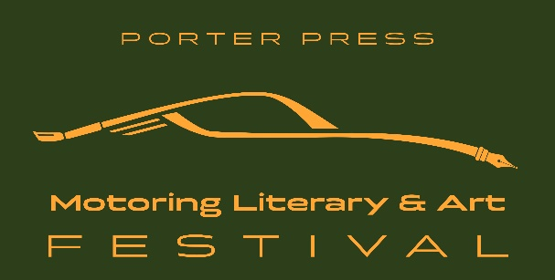
The Wing, Silverstone Circuit
2-3 December 2023

For immediate release 06/12/23
SHORT PRESS RELEASE FOR NEWSPAPERS

A Success, Literally!

- The first ever motoring literary festival
- Featuring Lord Hesketh, Karun Chandhok, Lee McKenzie, Andy Palmer, Jackie Oliver, Sir John Egan, Ian Callum, John Watson, Julian Thomson, John Fitzpatrick, Peter Stevens…
- Silent Auction in favour of Race Against Dementia
- Visitors from Europe, Canada and the USA
- Something new and different

‘A great success’ is the verdict on the world’s first Motoring Literary & Art Festival which took place at Silverstone last weekend.
In spite of dismal weather around 1000 attended the event organised by book publishers Porter Press International. ‘It was quite incredible,’ says Philip Porter whose idea the Festival was. ‘We had people who came especially from the USA, Switzerland, Belgium and Germany to attend.’
Over two days, some 24 sessions took place in three theatres with F1 drivers, famous designers, industry giants, authors and TV personalities from the motoring world. Subjects ranged from the future of the motor industry to ‘Blowing the bloody doors off’, from James Bond to the world’s first production Land-Rover which is owned by Sir Jim Radcliffe. Speakers ranged from Lord Hesketh talking about the F1 team he had at the age of 22 to Channel 4’s Lee McKenzie chatting with designer Gary Anderson about the F1 season and the prospects for 2024.
The speakers were complemented by 50 artists and exhibitors, a dozen publishers and a specially curated display of cars which included the world’s two most famous Jaguar E-types and a double Le Mans-winning Ferrari that is thought to be worth at least $50m.

For more information and to book – motorlitartfest.co.uk

Event Partners:
Coventry University | Guild of Motoring Writers | Alpine | Girardo & Co.

Media Partners:
Motor Sport magazine | Land Rover Monthly | CollectorsCarWorld

In support of:
Race Against Dementia

Full event details: motorlitartfest.co.uk
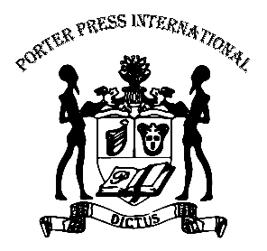
Porter Press International
Hilltop Farm, Knighton on Teme, Tenbury Wells, WR15 8LY, UK
info@porterpress.co.uk
Tel: +44 (0)1584 781588
www.porterpress.co.uk

